Sprint 1 - Endurance Design Document

November 9, 2021

Group 1

Kristina Shaw, Andrew McGovern, Michael Ivanicki

Table of Contents
1. Executive Summary 3
1.1 Project Overview 3
1.2 Purpose and Scope of this Specification 3
2. Product/Service Description 3
2.1 Product Context 3
2.2 User Characteristics 3
2.3 Assumptions 3
2.4 Constraints 3
2.5 Dependencies 4
3. Requirements 4
3.1 Functional Requirements 5
3.2 Security 5
3.2.1 Protection 5
3.2.2 Authorization and Authentication 5
3.3 Portability 5
4. Requirements Confirmation/Stakeholder sign-off 6
5. System Design 6
5.1 Algorithm 6
5.2 System Flow 6
5.3 Software 6
5.4 Hardware 6
5.5 Test Plan 6
5.6 Task List/Gantt Chart 6
5.7 Staffing Plan 7

Executive Summary

Project Overview

The Sphero robot is an excellent way for consumers to learn and fully understand the fundamentals of computer programming.
These projects, using the Sphero robot and Sphero Edu software, intend to allow the robot to complete the rectangular course, figure-8 course, and obstacle course all as quickly and accurately as possible and communicate our results to the Sphero consumers.

Purpose and Scope of this Specification

With our presented program, the consumer will be able to:
In Scope
- Have their Sphero robot complete the Endurance course: a rectangular perimeter around a room or flat surface
Out of Scope
- Have their robot complete the Accuracy course: a figure eight pattern
- Have their robot complete the Agility course: an obstacle course

Product/Service Description

Product Context

This product is one of three Sprints, one of four parts, to the Software Development Project. A diagram of the overall Software Development Project can be seen below.
Software Development Project
Sprint 1:  Endurance | Sprint 2:  Accuracy | Sprint 3:  Agility | Part 4:  Presentation

User Characteristics

This product pertains to users that fall under one or more of the following:
- Students and Faculty
  - Minimal experience required
  - Need to understand how to navigate the Sphero Edu software / application
- New or current programmers or Sphero users
  - Minimal experience required
  - May need experience in block coding if attempting to learn or edit program

Assumptions

The user is assumed to have:
- A computer, smart phone, tablet, or other smart device
- A Sphero robot
- The Sphero Edu application downloaded
- Access to the predetermined course for which the program is designed

Constraints

The following are possible constraints to the creation and design of the presented project:
- Room / space availability and access for testing the program
- Conflicting schedules of team members preventing meeting up

The following are possible constraints to the use of the presented project:
- Room / space availability and access for running the program on predetermined course
- Smart device current software status
- Smart device storage capacity

Dependencies

The following are dependencies in which will affect the run of the program:
- Room / floor space availability for the robot to move around
- Ability to download or recreate this product’s block code
- Access to a charged and functional Sphero robot

Requirements

Functional Requirements

Req# | Requirement | Comments | Priority | Date Rvwd | SME Reviewed / Approved
ENDUR_01 | Blue alignment light faces opposite direction of initial direction | Not explicitly required, but initial alignment is needed to start movement in correct direction | 2 | 10/27/21 | AM
ENDUR_02 | Robot starts in the first corner with the yellow square with a green light |  | 1 | 10/27/21 | AM
ENDUR_03 | Robot speaks “ready set go” |  | 1 | 10/27/21 | AM
ENDUR_04 | Robot starts moving and travels straight to the second corner |  | 1 | 10/27/21 | AM
ENDUR_05 | Robot stops at the second corner | Not explicitly required but improves accuracy and fulfillment of other requirements | 2 | 10/27/21 | AM
ENDUR_06 | Robot turns right to face third corner |  | 1 | 10/27/21 | AM
ENDUR_07 | Robot starts moving and travels straight to the third corner |  | 1 | 10/27/21 | AM
ENDUR_08 | Robot stops at the third corner | Not explicitly required but improves accuracy and fulfillment of other requirements | 2 | 10/27/21 | AM
ENDUR_09 | Robot turns right to face fourth corner |  | 1 | 10/27/21 | AM
ENDUR_10 | Robot starts moving and travels straight to the fourth corner |  | 1 | 10/27/21 | AM
ENDUR_11 | Robot stops at the fourth corner | Not explicitly required but improves accuracy and fulfillment of other requirements | 2 | 10/27/21 | AM
ENDUR_12 | Robot turns right to face first corner where it started |  | 1 | 10/27/21 | AM
ENDUR_13 | Robot starts moving and travels straight to the first corner |  | 1 | 10/27/21 | AM
ENDUR_14 | Robot stops at the first corner, at the original starting point | Not explicitly required but improves accuracy and fulfillment of other requirements | 2 | 10/27/21 | AM
ENDUR_15 | Robot color changes to red |  | 1 | 10/27/21 | AM
ENDUR_16 | Robot speaks “I’m done and I need water.” |  | 1 | 10/27/21 | AM
ENDUR_17 | Robot turns to face the second corner | Not required but would be nice to have the robot completely reset to the start position in order to run program again seamlessly | 3 | 10/27/21 | AM
ENDUR_18 | Robot avoided colliding with anything during entire run | Will not be in the code, just an understood requirement | 1 | 10/27/21 | AM

Security

Protection

The security measure that our team took to ensure the protection of our data and code was that our project files were only saved on devices with passwords. This was to ensure that nobody outside of our group could access our work and potentially alter what we had done. Any files related to the project were saved on these secure devices and all access to files or code were restricted to private, so that only we could see and access them.
Because this program is simply for a class project, no extra security measures designed by our team are required for protection from malicious intent.

Authorization and Authentication

To run the program, a user must be logged into a smart device that has the Sphero Edu application, and they must log into Sphero Edu as well to access an account that has access to the block code.
The original block code program is on Sphero Edu account: drewmcgovern

Portability

The smart devices (computers, phones, etc.) that run the Sphero Edu application are portable, the Sphero robot is portable, and the block code is portable to other smart devices from the host device as well.
While the device running the code and the robot are both portable, they must be connected to each other via Bluetooth while the program is running, so the device and the robot must be in close proximity with each other.
The predetermined track for the project is not portable as it can only be found on the floor of Howard Hall Room 208.

Requirements Confirmation/Stakeholder sign-off

Meeting Date | Attendees (name and role) | Comments
10/27/21 | Kristina Shaw | Confirmed all
10/27/21 | Michael Ivanicki | Confirmed all
10/27/21 | Andrew McGovern | Confirmed all

System Design

Algorithm

- Start program
- Set light to green
- Output audio “Ready, set, go”
- Roll forward at 0 degrees at a set speed and set time
- Stop rolling and delay for a set time
- Roll to the right at 90 degrees at a set speed and set time
- Stop rolling and delay for a set time
- Roll backwards at 180 degrees at a set speed and set time
- Stop rolling delay for a set time
- Roll to the left at 270 degrees at a set speed and set time
- Stop rolling and delay for a set time
- Set light to red
- Output audio “I’m done and I need water”
- End program

System Flow
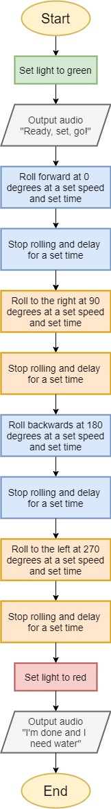

Software

The main software used for this project is the Sphero Edu application. This software is how our team constructed and edited the code, connected to the robot, and ran the program with the robot.
We also used Windows, Mac, Linux, and iOS operating systems to use the Sphero Edu application. These operating systems allowed us to download and install the Sphero Edu application, so these were also vital aspects of our project as well.
The block code for the project is embedded below.
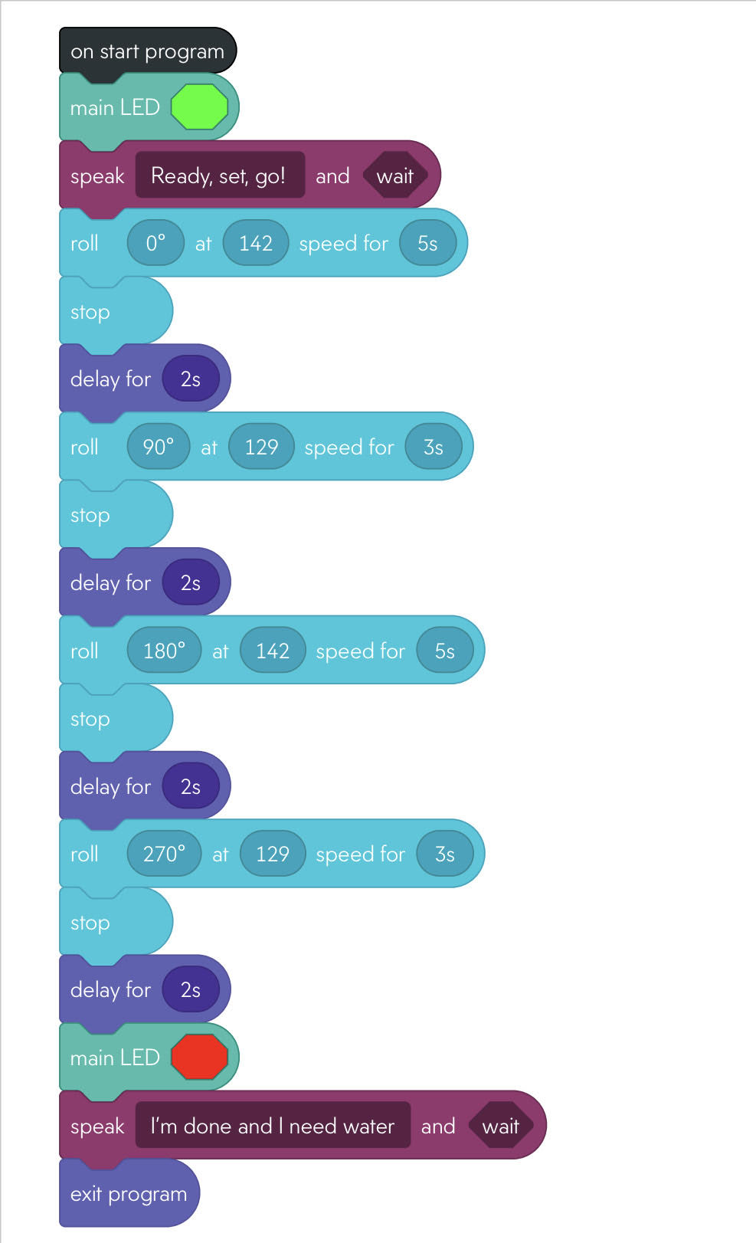

The Sensor Data Diagram is embedded below.

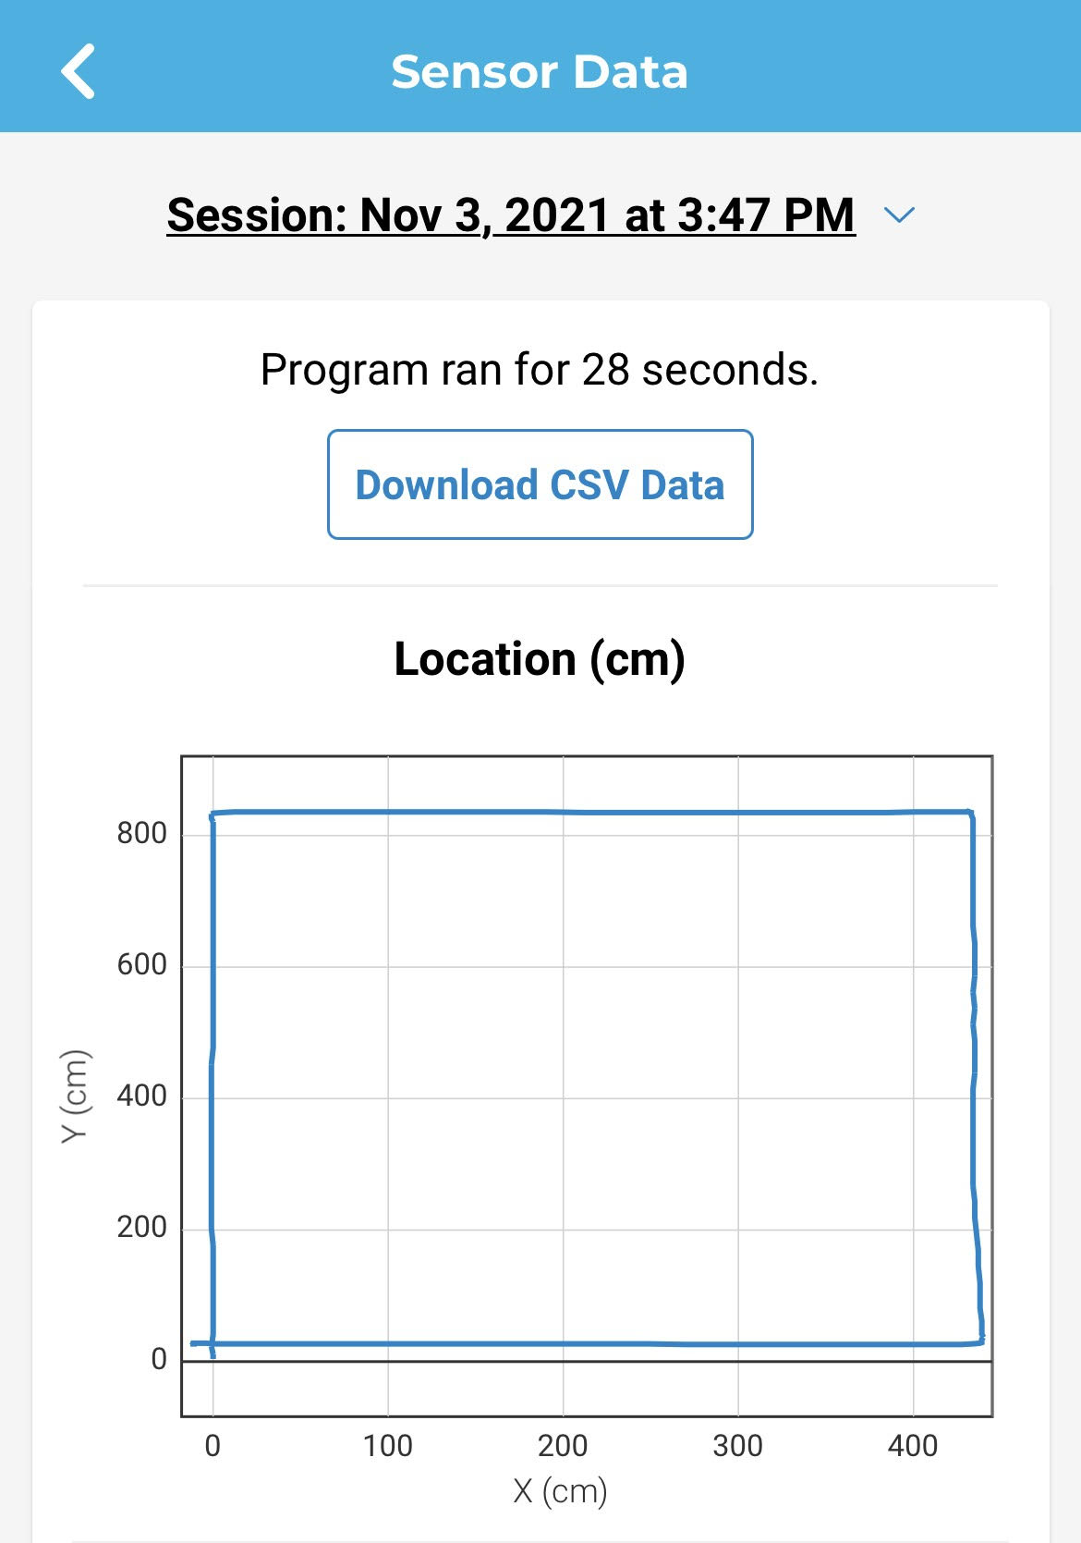

Hardware

The main hardware devices we used to run the software and develop the project were laptops and phones. We used both device types to run the software mentioned in the previous section, in order to complete the project. Specifically, it allowed us to construct and test the code and to wirelessly connect with our robot, but all aspects of the project can be attributed to the hardware, since we would not have been able to complete any of the tasks without the hardware.
Also, the Sphero robot and charging station were obviously essential to the completion of the project, as a functional and powered Sphero robot is needed in order to run the program.

Test Plan

Reason for Test Case | Test Date | Expected Output | Observed Output | Staff Name | Pass/Fail
Testing for shorter side of rectangle at 100 speed for 3 seconds | 11/3 | Robot moves from one corner of shorter length to other corner of shorter length and stops at the corner | Robot did not make it to the other corner of the shorter length | AM | Fail
Testing for shorter side of rectangle at 150 speed for 3 seconds | 11/3 | Robot moves from one corner of shorter length to other corner of shorter length and stops at the corner | Robot overshot the other corner of the shorter length | AM | Fail
Testing for shorter side of rectangle at 130 speed for 3 seconds | 11/3 | Robot moves from one corner of shorter length to other corner of shorter length and stops at the corner | Robot slightly overshot the other corner of the shorter length | AM | Fail
Testing for shorter side of rectangle at 129 speed for 3 seconds | 11/3 | Robot moves from one corner of shorter length to other corner of shorter length and stops at the corner | Robot successfully made it to the other corner of the shorter length and stopped | AM | Pass
Testing for longer side of rectangle at 130 speed for 5 seconds | 11/3 | Robot moves from one corner of the longer stretch to other corner of longer stretch and stops at the corner | Robot did not make it to the other corner of the longer stretch | AM | Fail
Testing for longer side of rectangle at 140 speed for 5 seconds | 11/3 | Robot moves from one corner of the longer stretch to other corner of longer stretch and stops at the corner | Robot slightly did not make it to the other corner of the longer stretch | AM | Fail
Testing for longer side of rectangle at 145 speed for 5 seconds | 11/3 | Robot moves from one corner of the longer stretch to other corner of longer stretch and stops at the corner | Robot slightly overshot the other corner of the longer stretch | AM | Fail
Testing for longer side of rectangle at 143 speed for 5 seconds | 11/3 | Robot moves from one corner of the longer stretch to other corner of longer stretch and stops at the corner | Robot slightly overshot the other corner of the longer stretch | AM | Fail
Testing for longer side of rectangle at 142 speed for 5 seconds | 11/3 | Robot moves from one corner of the longer stretch to other corner of longer stretch and stops at the corner | Robot successfully made it to the other corner of the longer stretch and stopped | AM | Pass
Testing for a full run of the program including lights, audio, traveling, stopping, delaying, and turning | 11/3 | Robot successfully completes the course and meets all the requirements with lights and sounds | Robot was not lined up correctly at the start and went off course and hit the wall | AM | Fail
Testing for a full run of the program including lights, audio, traveling, stopping, delaying, and turning | 11/3 | Robot successfully completes the course and meets all the requirements with lights and sounds | Robot bumped on some of the taped ripped on the ground and was slightly knocked off course | AM | Fail
Testing for a full run of the program including lights, audio, traveling, stopping, delaying, and turning | 11/3 | Robot successfully completes the course and meets all the requirements with lights and sounds | Robot was not lined up correctly at the start and went off course to the right towards the tables in the middle | AM | Fail
Testing for a full run of the program including lights, audio, traveling, stopping, delaying, and turning | 11/3 | Robot successfully completes the course and meets all the requirements with lights and sounds | Robot bumped on some of the taped ripped on the ground and was slightly knocked off course | AM | Fail
Testing for a full run of the program including lights, audio, traveling, stopping, delaying, and turning | 11/3 | Robot successfully completes the course and meets all the requirements with lights and sounds | Robot successfully completed course accurately and fulfilled all requirements, returning to the start | AM | Pass
Testing for a second consecutive successful run of the program | 11/3 | Robot successfully completes the course and meets all the requirements with lights and sounds | Robot successfully completed course accurately and fulfilled all requirements, returning to the start | AM | Pass
Testing for a third consecutive successful run of the program | 11/3 | Robot successfully completes the course and meets all the requirements with lights and sounds | Robot successfully completed course accurately and fulfilled all requirements, returning to the start | AM | Pass

Task List/Gantt Chart

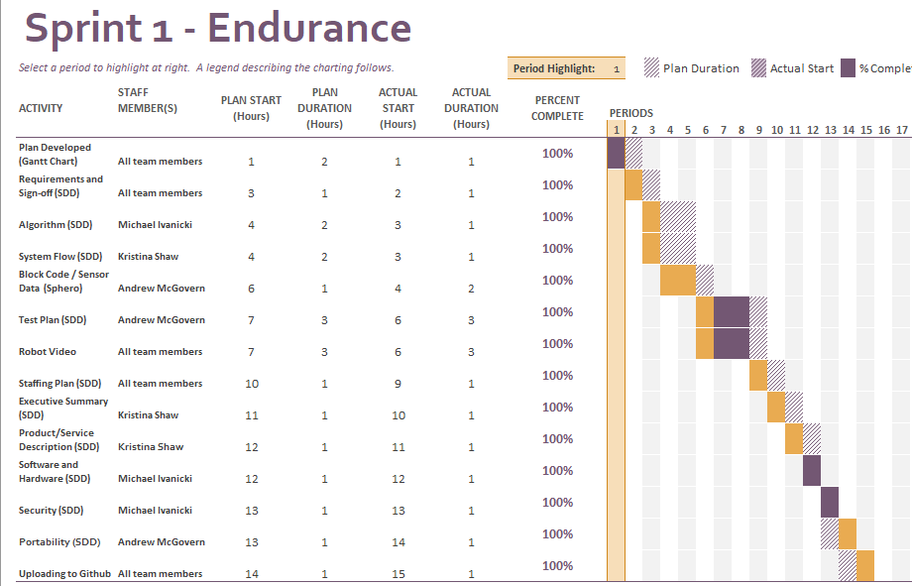

Staffing Plan

Name | Role | Responsibility | Reports To
Andrew McGovern | Subject-matter Expert, Team Programmer, Test Plan Manager | Understood requirements and took charge of the requirements table and the SDD and the Gantt Chart, took charge of the main device used for programming, track the test plans and outcomes | Prof. Eckert
Kristina Shaw | Team Manager, Product Communicator, Video Manager | Organized meeting times and scheduling, took charge of Executive Summary and Product Service / Description, recorded robot during test runs | Prof. Eckert
Michael Ivanicki | Algorithm Manager, Device expert, Video Manager | Took charge of algorithm and planning for code, took charge of Software, Hardware, and Security Descriptions, recorded robot during test runs | Prof. Eckert

